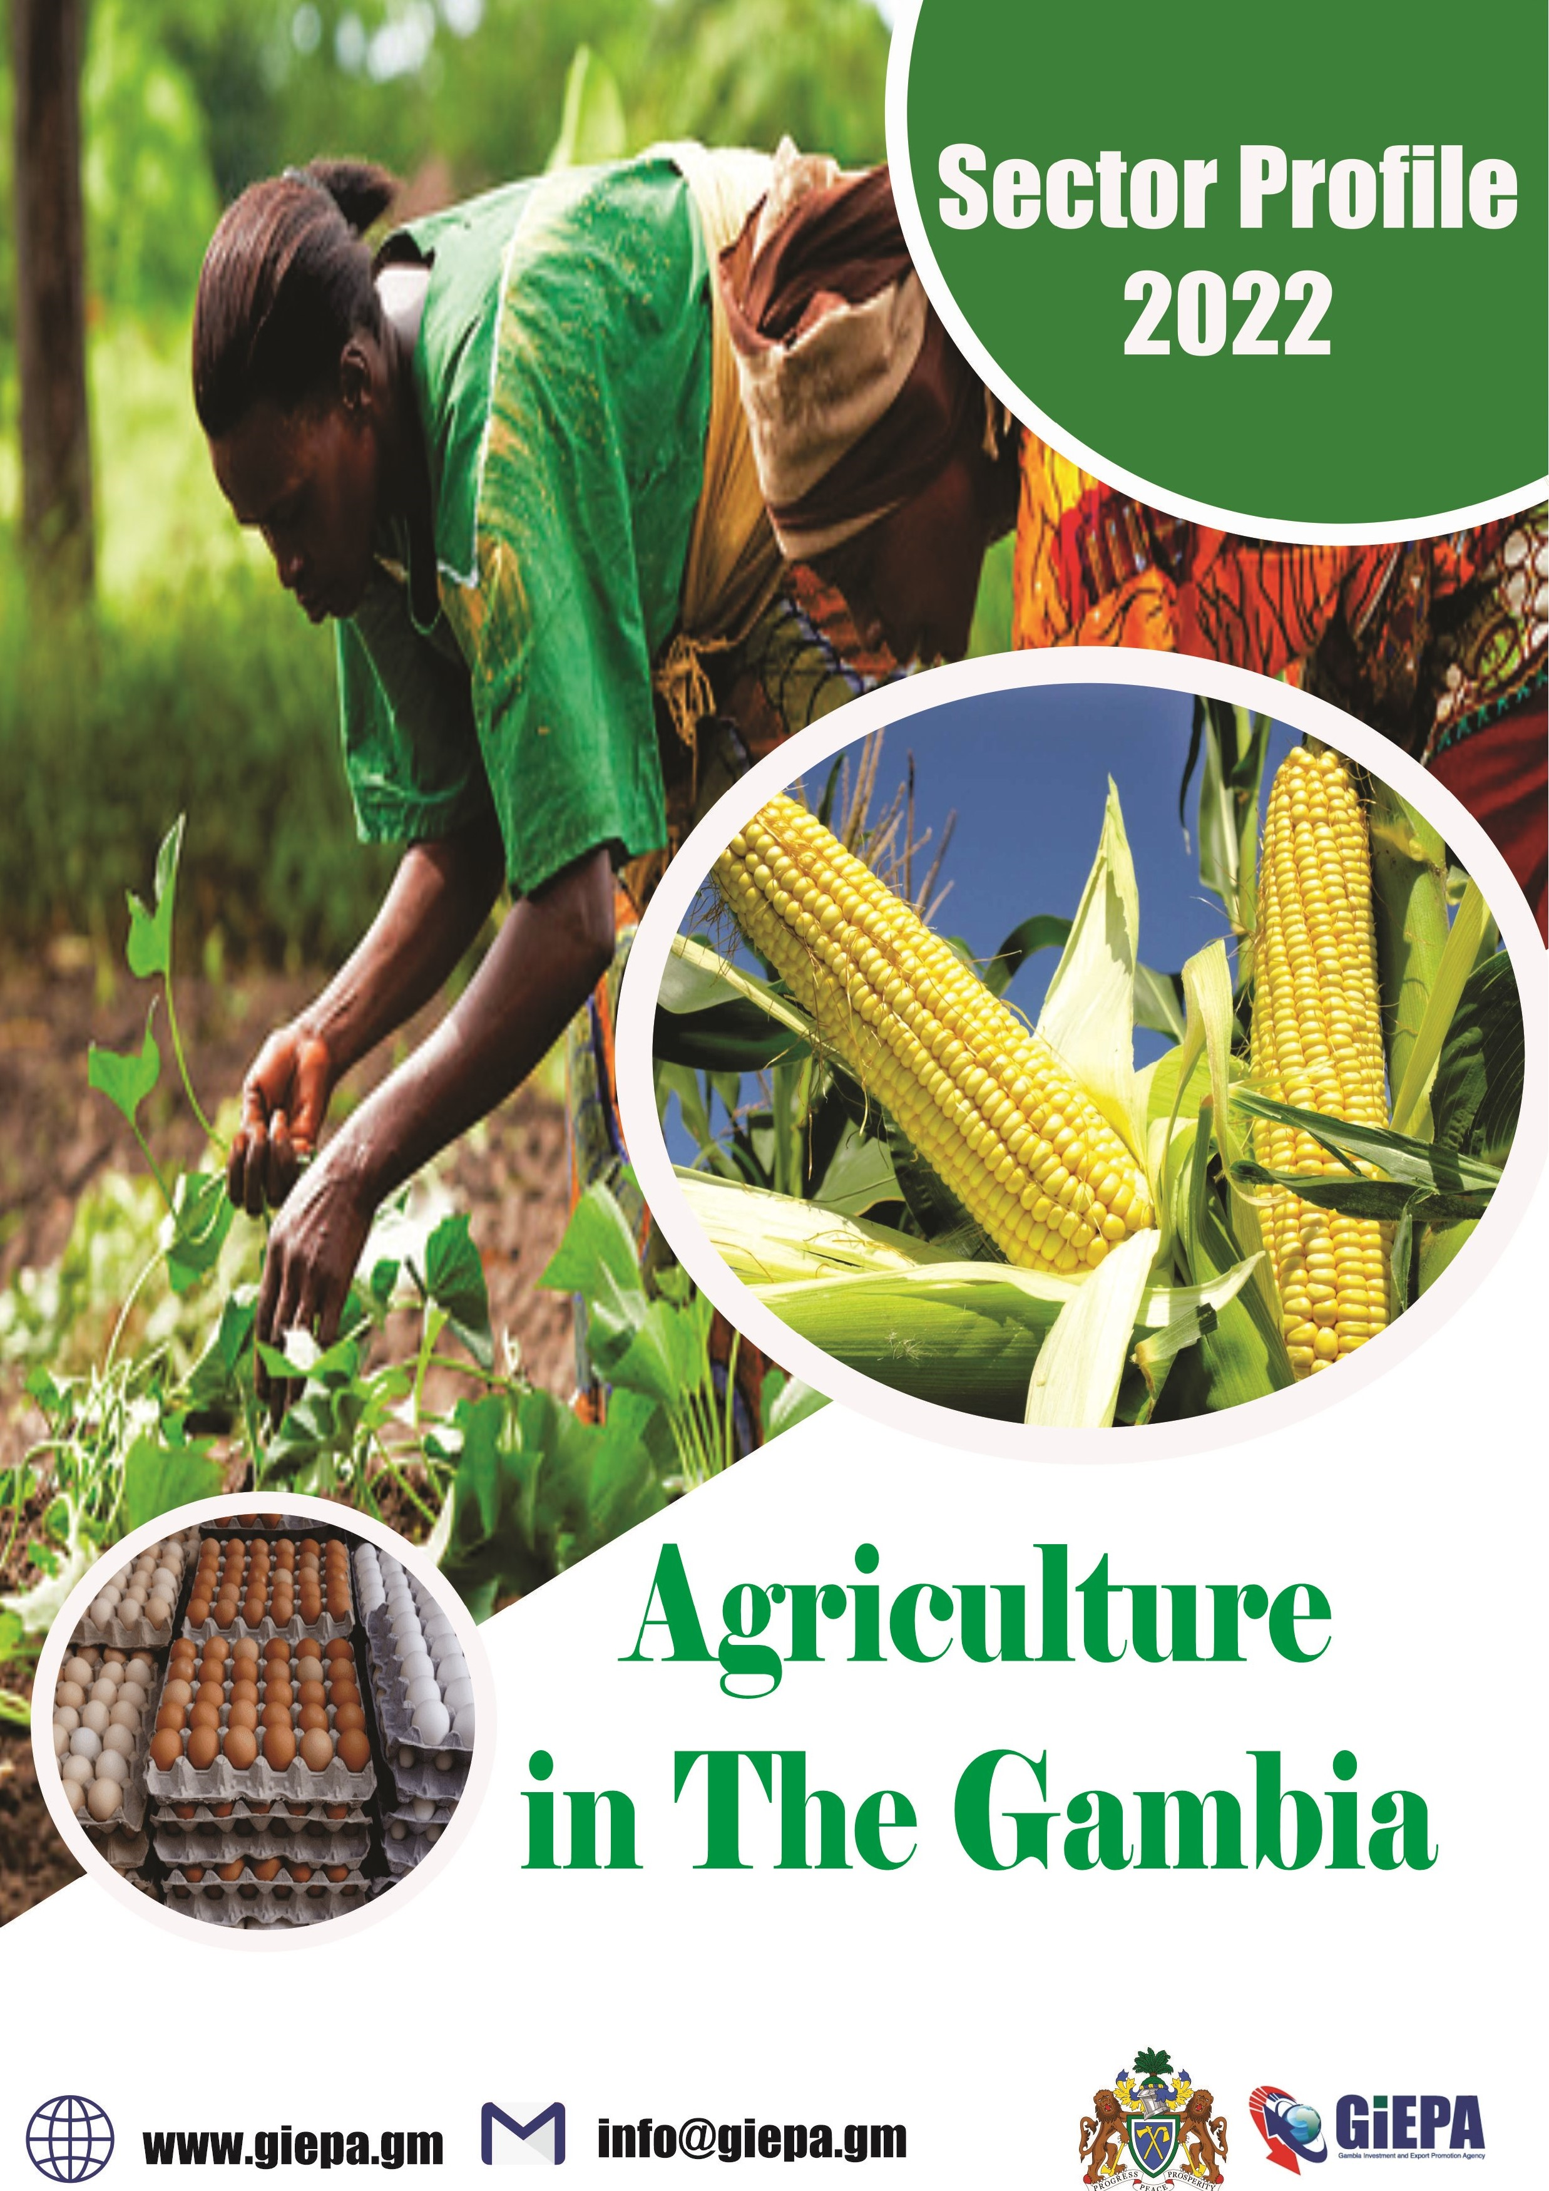

Agriculture In The Gambia

Table of Content
Why The Gambia…………………………………………………………………… 1
Economic Indicators………………………………………………………………. 2 Infrastructure………………………………………………………………………… 3 Groundnut Production in The Gambia…………………………………… 4
Maize Production in The Gambia…………………………………………… 7
Beef Cattle Rearing in The Gambia………………………………………… 9
Cashew Production in The Gambia……………………………………….. 11
Dairy Cattle Rearing in The Gambia………………………………………. 14 Poultry Rearing in The Gambia……………………………………………… 16
Seed Production in The Gambia…………………………………………….18 Export Agreement………………………………………………………………...21
Incentive……………………………………………………………………………….21
Government Policies……………………………………………………………..22
Operational Cost……………………………………………………………………22
Why Invest in The Gambia……………………..…………………..………...23-24
A helping hand every step of the way…………………………………...24
Reference……………………………………………………………………………..25

Why The Gambia?
Situated on the Atlantic coast and with a navigable river that flows more than 1,100km inland. The Gambia is the ideal entry and exit point for West Africa and the Economic Community of West African States (ECOWAS).

This document outlines:
The market opportunity for investment in agricultural sector.
The favorable conditions available to investors.
The support investors can expect to receive.
The project risk and sustainability factors to be considered.
The most competitive country in West Africa |  | Average Crop Production one of the highest in West Africa
Home to the only West African river easily accessible to ocean-  going shipping |  |  | One of the best Agricultural Policy Framework in West Africa
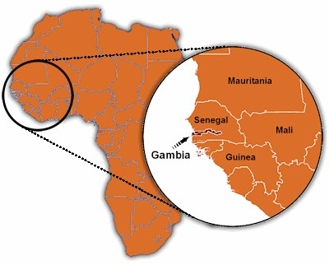
1

Economic Indicator
- GDP: US$2,036mm in 2021.
- GDP growth: 4.3% in 2021.
- Country risk: Lower risk level (yellow) than all neighboring countries
- CPI Inflation (2021): 7.607
- Exports / Imports value (2020) : - Exports: $28.7mm Import: $725.7mn.
- Labor force (2019) : 781,558
- FDI stock and inflows (2020): $519.217mm stock / $46mm inflows.
- Currency exchange rates (2021) – highs (H) and lows (L):
- GMD/USD: 52.61 (H)/51.07(L)
- GMD/GBP:71.1(H)/ 68.24(L).
- GMD/EUR: 61.87 (H)/60.57(L)
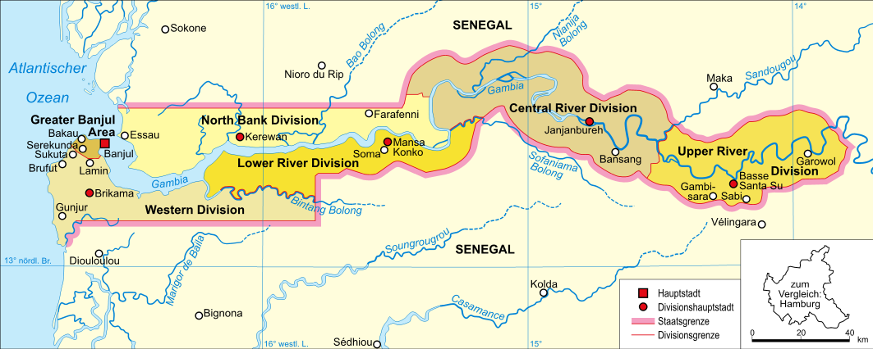
2
Infrastructure

- Banjul port has a handling capacity of
⇒ 48 metric tonnes of bulk cargo per hour.
⇒ 17 container moves (discharging and loading) per hour.
- Other new infrastructure / upgrades in development.
- The Trans-Gambia bridge.
- Improved cross-border trunk roads with Senegal.
- Ports Expansion Programme underway.
- Gambia Ports Authority planning to build a second port on the Atlantic coast.
- Ongoing infrastructure upgrades at Banjul International Airport.
- Gambia Port Authority is assessing the potential establishment of an inland port to facilitate shipping to inland location across the region.
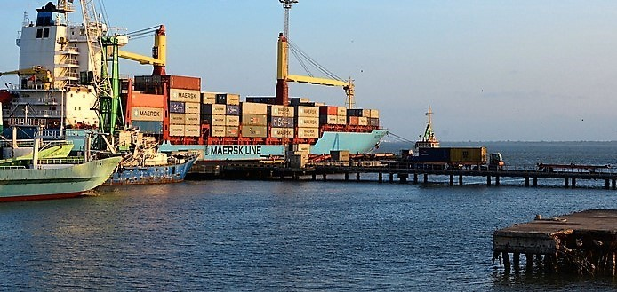
3

Groundnut Production in The Gambia

- Groundnut is the main cash crop in the countries economy.
- The Gambia offers the ideal environment for groundnut production in terms of arable land, climate, know-how and available skills.
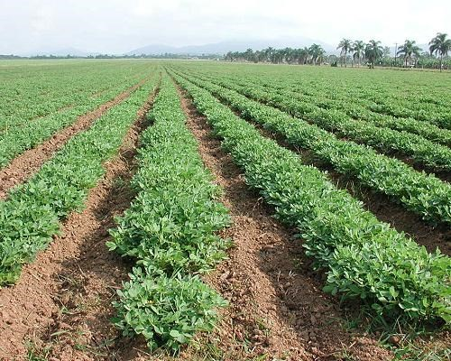
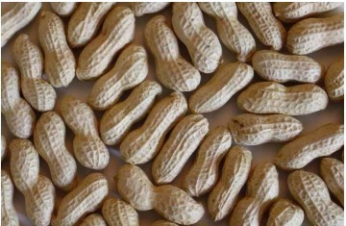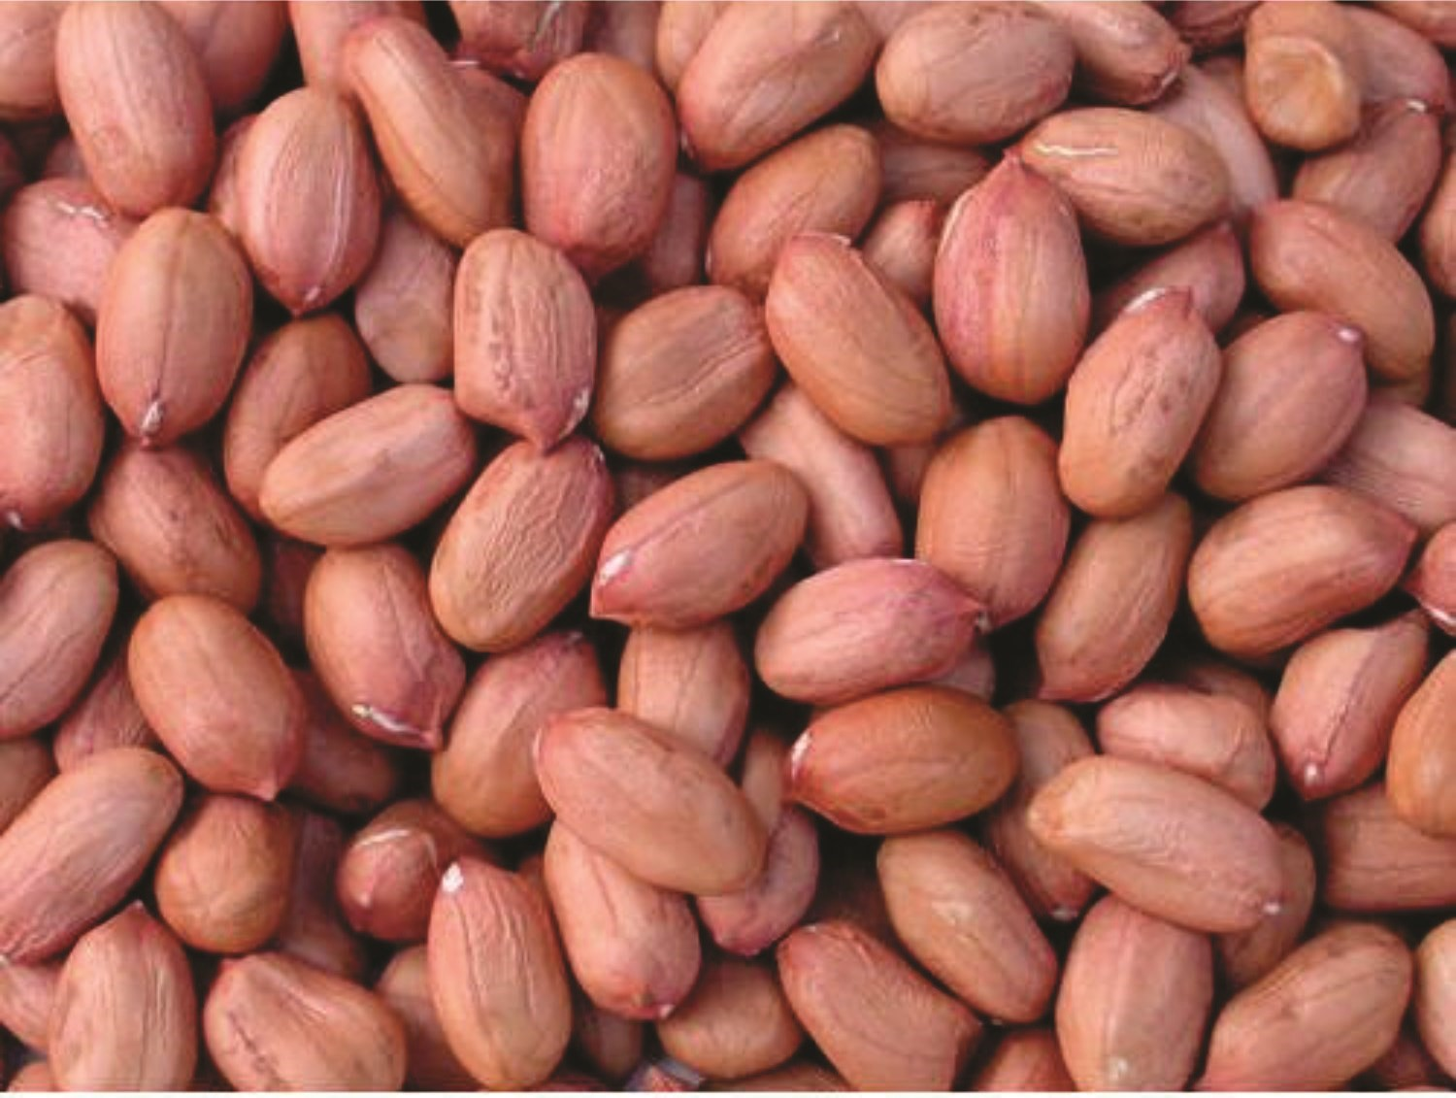
4
By-products and processing
- Groundnuts are the base of a diverse set of products – a recent report by the US Department of Agriculture’s Foreign Agricultural Service stated it is possible to derive 63 derivatives products from raw peanut – a small selection of these are presented here.
- Investors in groundnut production in The Gambia therefore have the opportunity not only to export raw nuts, but also to consider processing activities that would enable value added products to be developed and sold at a premium.
- Very little groundnut processing is currently done in the Gambia, and many current exports are sold as low-value products (e.g. birdfeed) - this presents an untapped area of potential investment.
Roasted & salted peanuts | Groundnut oil | Peanut butter
Peanut flour | Soaps | Shampoos
Dyes | Fertilizer | Bioenergy from sheshells
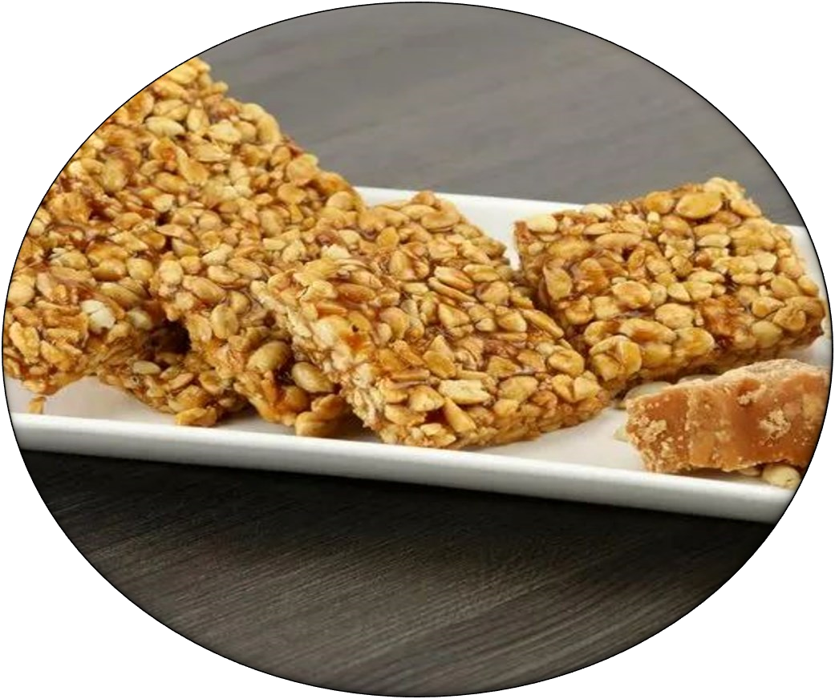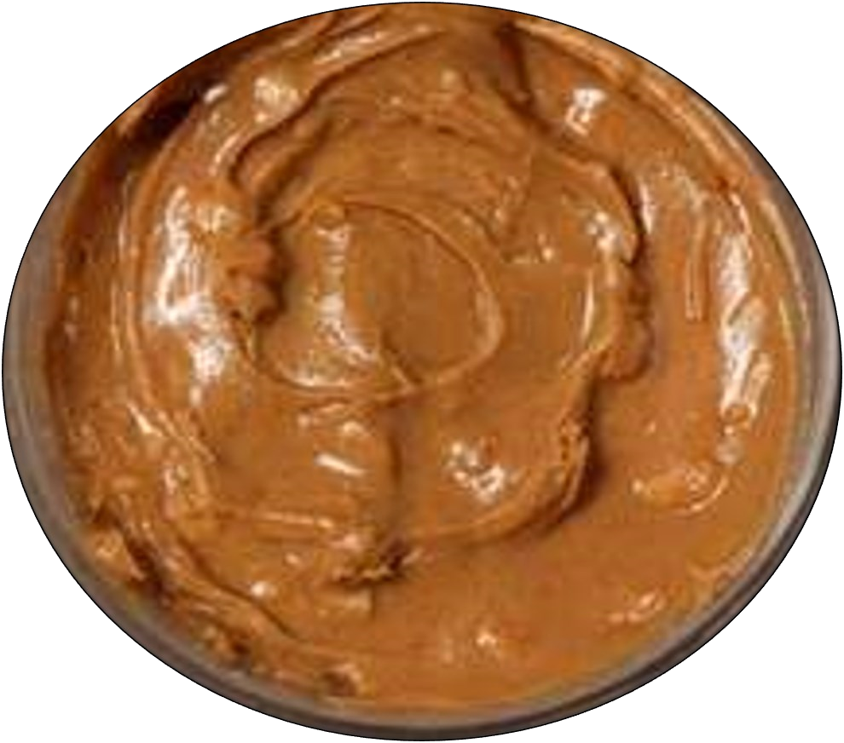

5
The Gambia Groundnut Community

- The Gambia is already home to a developed community of stakeholders in the groundnut industry (including businesses, industry associations and representative groups) - a few examples of these organisations are displayed below.
- The presence of these groups demonstrates The Gambia’s attractiveness and potential as a prime location in West Africa for the production, small-scale processing and export of groundnuts and related products. EXAMPLES OF ORGANISATION
Agribusiness Services & Producers Association (ASPA) | ComAfrique  Ltd. | Ghatson  Company  Gambia Ltd | Gambia Groundnut Corporation
GreenTech | Gambia  Farmers | Reliance oil mills | New Nut Company

“
I think we entered the (Gambian) market at a very exciting time, when govern-
ment is trying to prioritize cum mechanize and make the agriculture sector more
attractive
”

Momodou S Samateh

Director of Administration

New Nut Company

Location
- Groundnuts can be grown in almost all parts of The Gambia, with current production concentrated along the north bank and south bank areas.
- The west coast offers easy access to Banjul port and airport, while the north and south roads and navigable river ensure easy access from the rest of the country.
6

Maize Production in the Gambia
- With arable, irrigable land surrounding one of West Africa’s largest and most navigable rivers, The Gambia offers the ideal environment for the production of maize.
- However, The Gambia currently only produces half of its domestic cereals requirement and is heavily reliant on expensive imports.
- The Gambia has the potential to produce more maize.
 less than 60% of the country’s arable land resources is used.
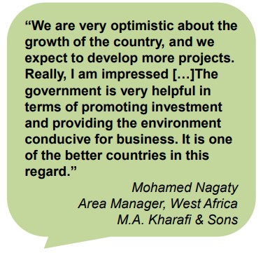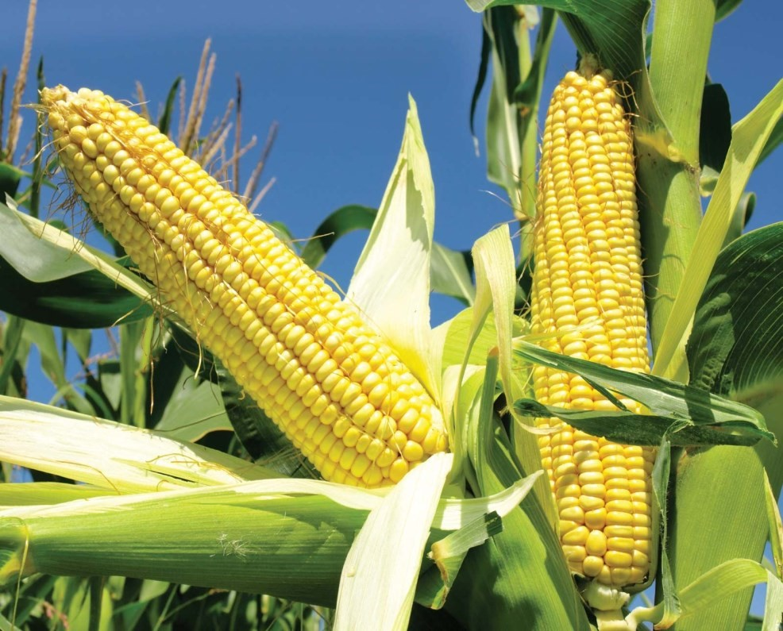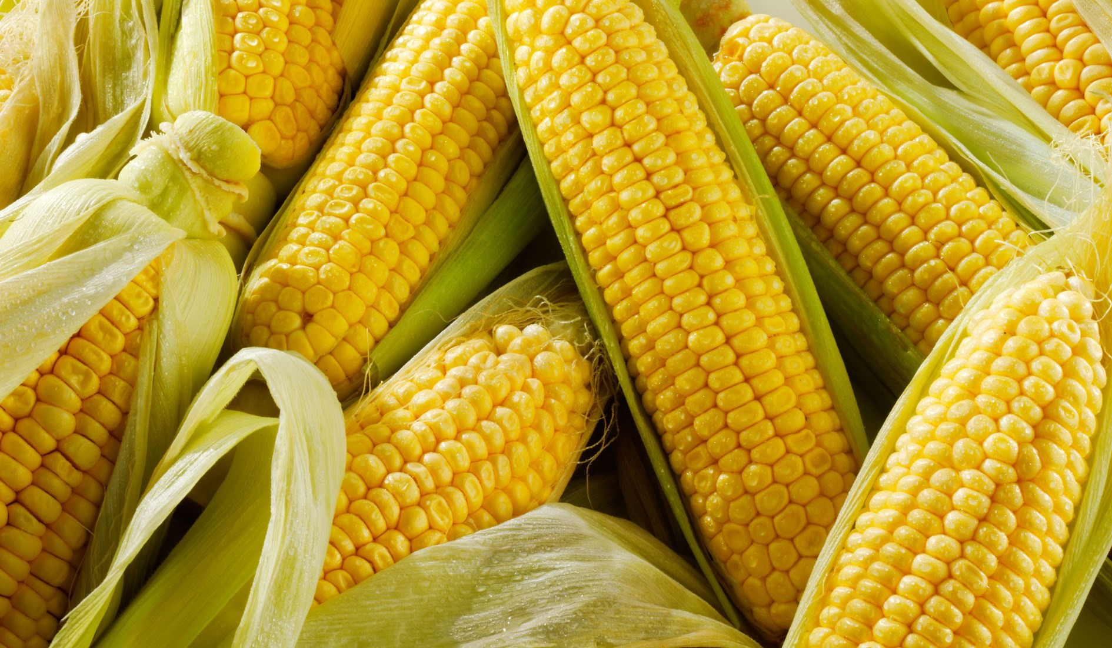

7
The Gambia Cereal Community
- The Gambia is already home to a developed community of stakeholders in the cereals sector, including maize. The community consists of businesses, industry associations and representative groups. A few examples of these organizations are displayed below.
- The presence of these groups demonstrates The Gambia’s attractiveness and potential as a prime location in West Africa for the production and small-scale processing of maize.

Agribusiness Services  & Producers' Associa- | Empass Farm Ltd. | ComAfrique Ltd.
MAK Farm Foods (M.A.  Kharafi & Sons Co. Ltd.) | National Agricultural  Research Institute | Gambia Farmers  Platform
National Women Farmers Association | Njawara Agricultural  Training Centre (NATC)

Location
- Maize can be grown in several locations throughout The Gambia, with current production concentrated in the north bank region (Kerewan).
- The west coast offers easy access to Banjul port and airport, while the north and south roads and navigable river ensure easy access from the rest of the country.

8
Beef Cattle Rearing in The Gambia

- The Gambia offers the ideal environment for beef cattle rearing in terms of grazing land, climate, know-how and available skills.
- This ideal environment is bolstered by political support – and an established target – to increase the supply of livestock products to the tourism.

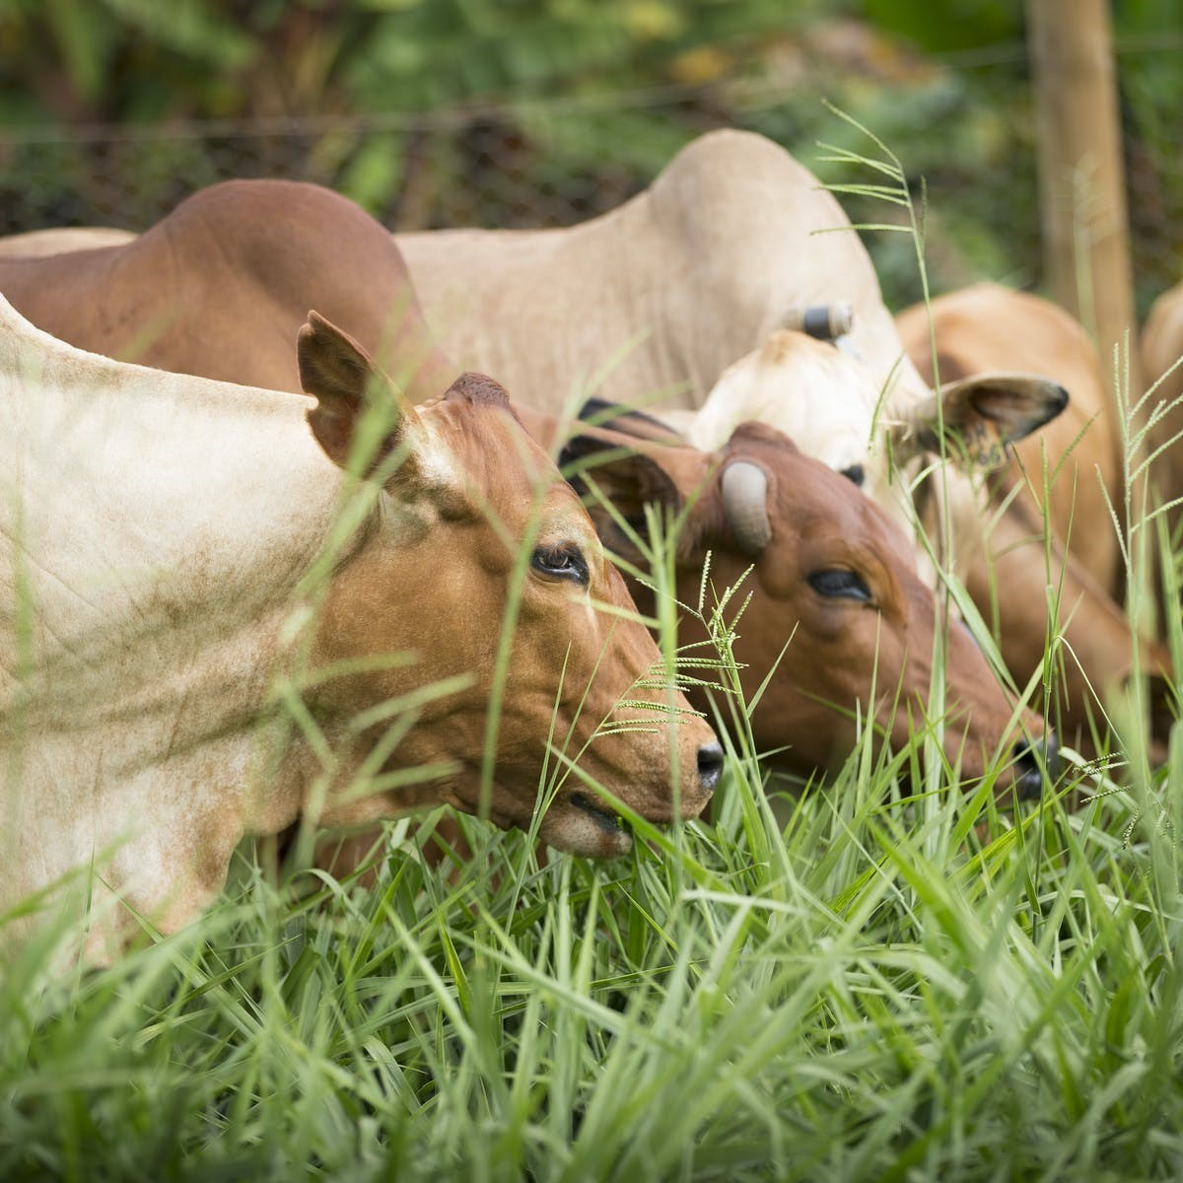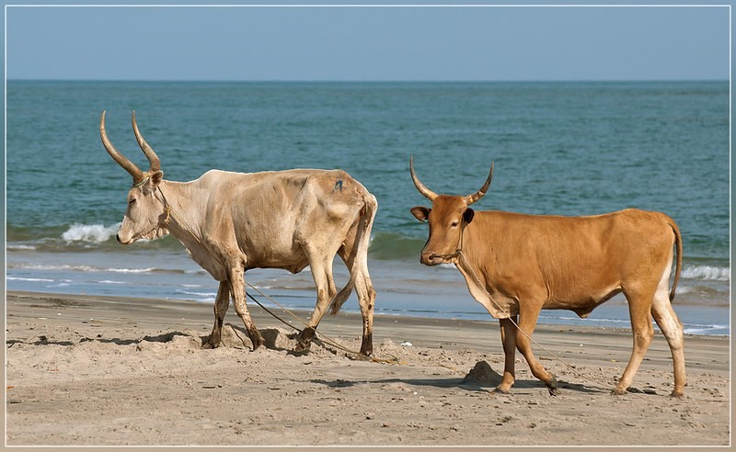

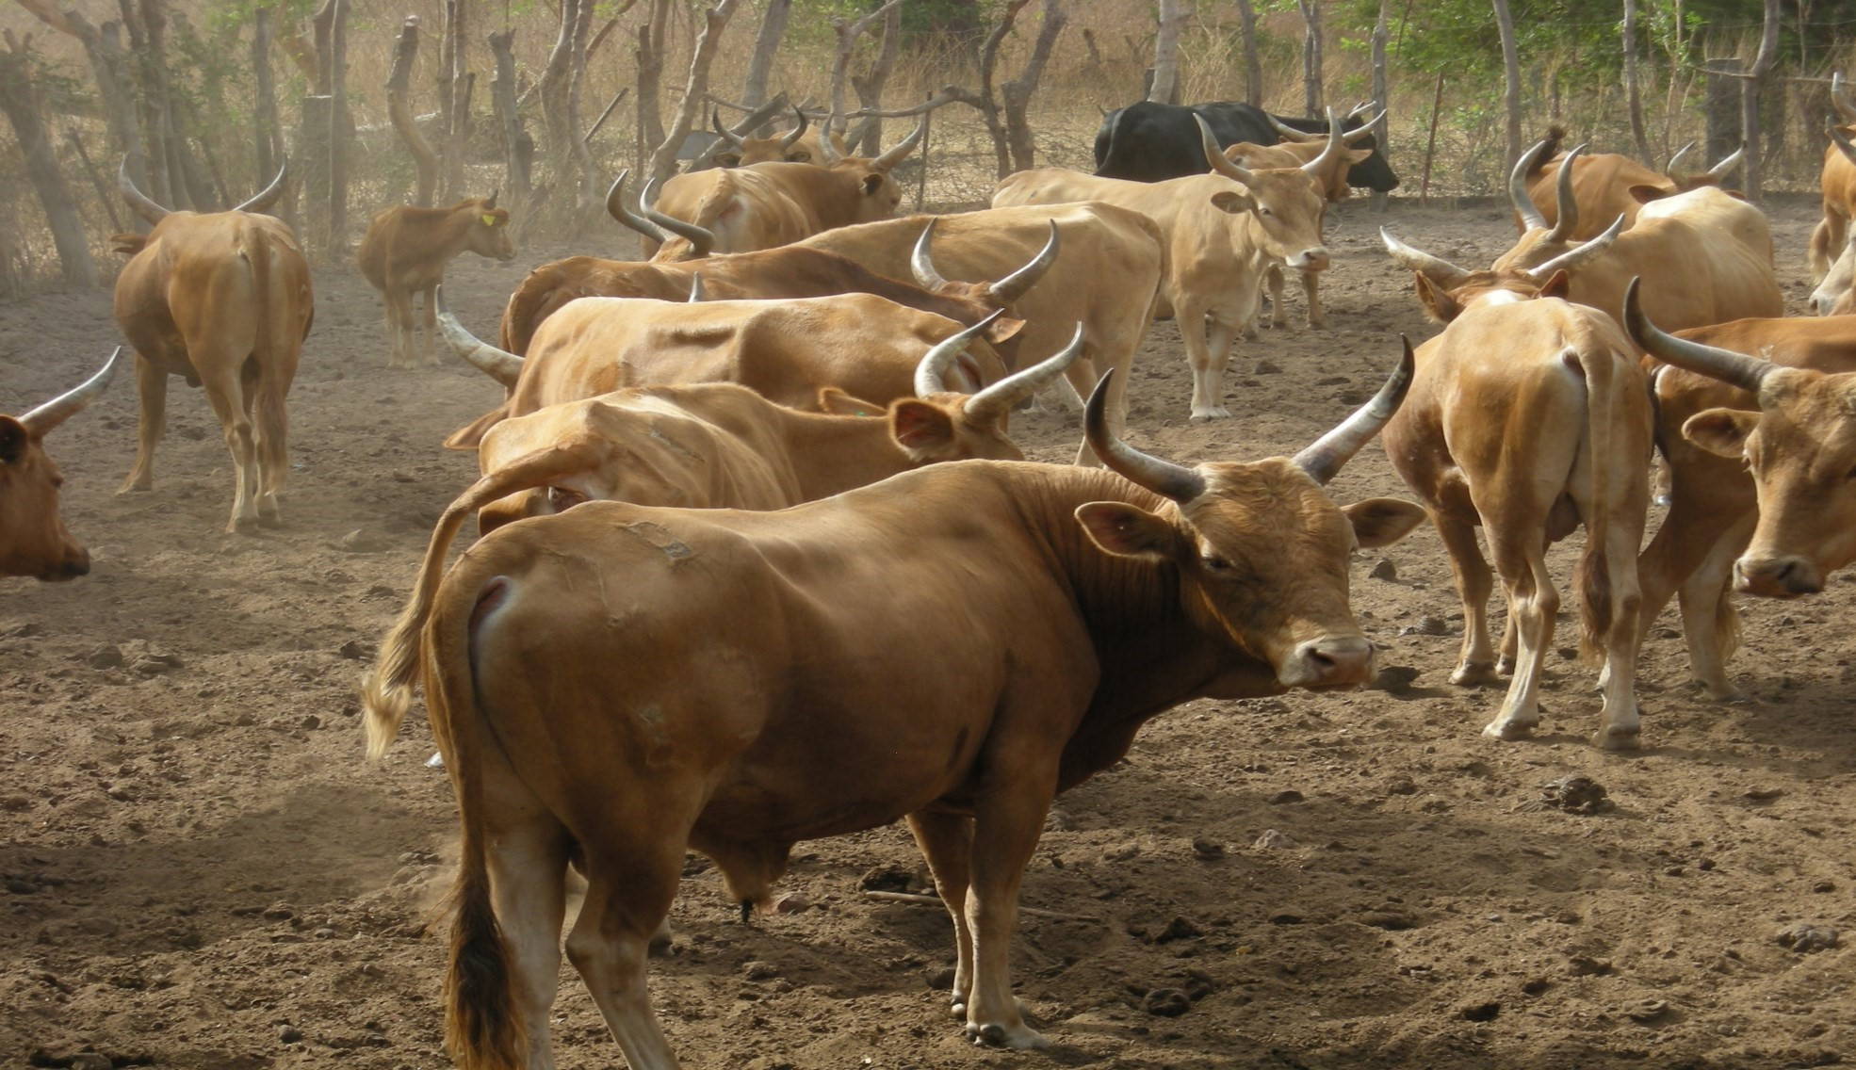

9
The Gambia’s Livestock community
- The Gambia is already home to a developed community of stakeholders in the livestock industry (including businesses, industry associations and representative groups) – a few examples of these organisations are displayed below.
- The presence of these groups demonstrates The Gambia’s attractiveness and potential as a prime location in West Africa for the rearing of livestock. Cattle is currently an under-exploited area of investment (existing investors typically rear other livestock). Given the existing cattle stock, livestock dealers and butchers however, beef cattle offers important investment opportunities.

EXAMPLES OF ORGANISATION

Gambia Livestock Marketing Agency | Kombo Farms Gambia Co. Ltd.
Gambia Farmers Platform | Kanilai Family Farms
Location
- Beef cattle can be reared in many parts of The Gambia, with current livestock production concentrated in the Upper and Central River Regions.
- The west coast offers easy access to Banjul port and airport, while the north and south roads and navigable river ensure easy access from the rest of the country.
10

Cashew Production in The Gambia

- The Gambia offers the ideal environment for cashew production in terms of arable land, climate, know-how and available skills.
- Cashew plantations in The Gambia are relatively young with production potential expected to rise significantly within the next decade.
- The average Gambian cashew is larger in size than in competing countries (as measured by the lower average nut count per kg).
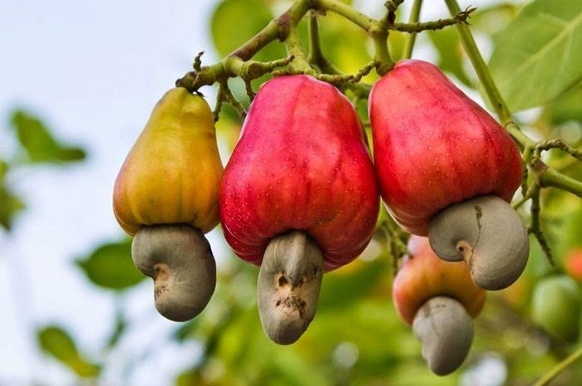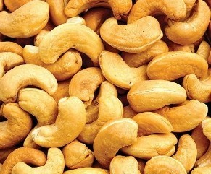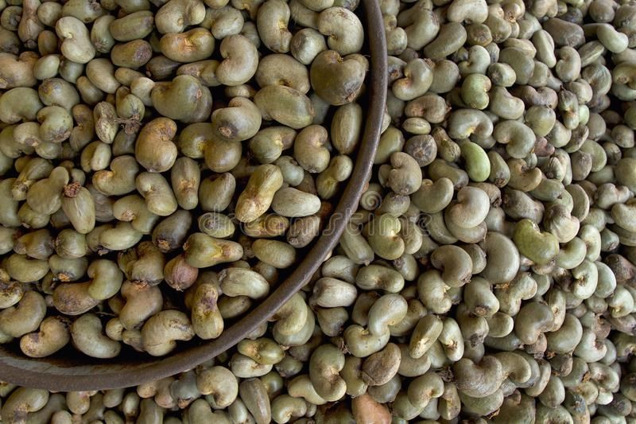

11

By-Products and Processing Potentials
- Cashews are the base of a very extensive and diverse set of products (listed below).
- Investors in cashew production in The Gambia therefore have the opportunity not only to export raw cashew, but also to consider processing activities that would enable value-added products to be developed and sold at a premium.
- Very little cashew processing is currently done in the Gambia, although organisations like International Relief & Development (IRD) are supporting the development of cashew processing capabilities - this presents an untapped area of potential investment.
COMMODITY | VALUE-ADDED PRODUCTS
Nut | Roasted/salted nuts, speciality nuts (e.g. spicy / chocolatecovered), cashew nut butter
Apple | Juice, jam, wine, distilled liquor, couscous, dried fruit
Peel | Animal feed
Shell | Fuel source
12

The Gambia’s Cashew Community

- The Gambia is already home to a developed community of stakeholders in the cashew industry (including businesses, industry associations and representative groups). A few examples of these organisations are displayed below.
- The presence of these groups demonstrates The Gambia’s attractiveness and potential as a prime location in West Africa for the production, processing and export of cashews and related products.

EXAMPLES OF ORGANISATIONS
Cashew Gam Company Ltd. | ComAfrique Ltd. | Ghatson Company Gambia Ltd. | Jawneh and Family
National Cashew Growers and Traders Corp | Gambia Farmers  Platform | Federation of Gambia Cashew Farmers | International Relief &  Development (IRD)
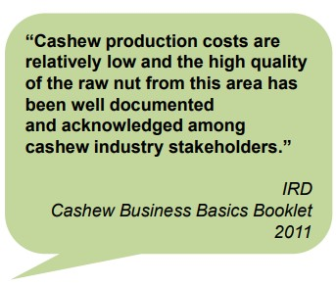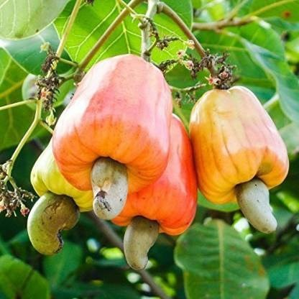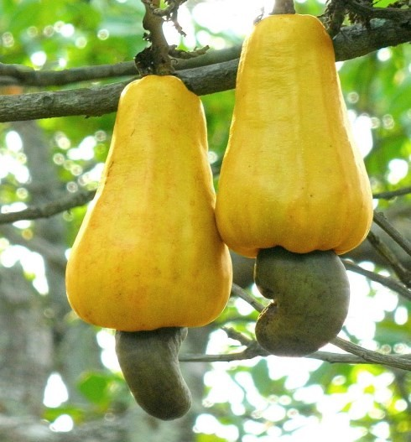
Location

 Cashews can be grown in almost all parts of The Gambia, with current production concentrated along the north bank and west coast areas.
 The west coast offers easy access to Banjul port and airport, while the north and south roads and navigable river ensure easy access from the rest of the country.
13

Dairy Cattle Rearing in The Gambia

- The Gambia offers the ideal environment for dairy cattle rearing in terms of grazing land, climate, know-how and available skills.
- The Gambia is heavily reliant on dairy imports.
- This ideal environment is bolstered by political support – and an established target – to increase the supply of livestock products to the tourism sector.

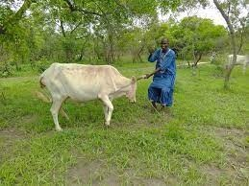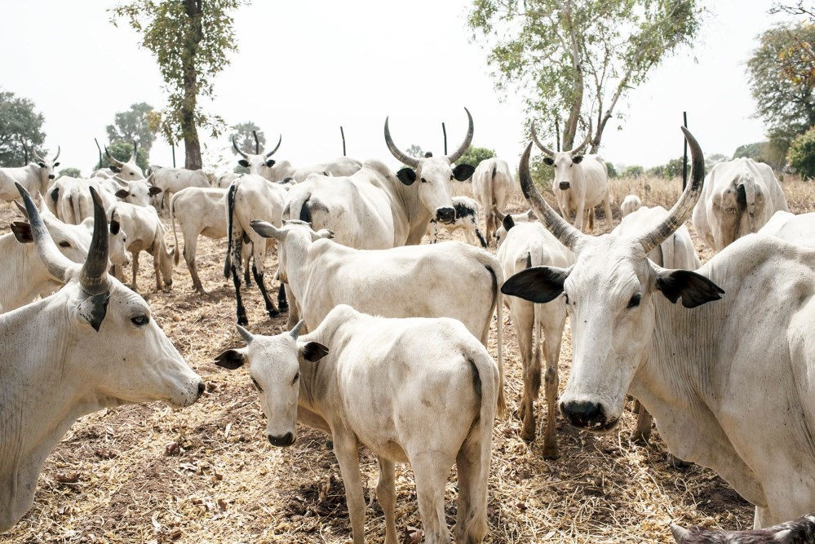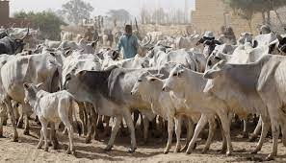

14

Gambia Livestock Community in The Gambia
- The Gambia is already home to a developed community of stakeholders in the livestock industry (including businesses, industry associations and representative groups) – a few examples of these organisations are displayed below.
- The presence of these groups demonstrates The Gambia’s attractiveness and potential as a prime location in West Africa for the rearing of livestock. Cattle is currently an under-exploited area of investment (existing investors typically rear other livestock). Given the existing cattle stock and livestock dealers however, dairy cattle offers important investment opportunities.
EXAMPLES OF ORGANISATIONS:
Gambia Livestock Marketing Agency | Kombo Farms Gambia Co. Ltd.
Gambia Farmers Platform | Cattle Traders Association

Location

- Dairy cattle can be reared in many parts of The Gambia, with current livestock production concentrated in the Upper and Central River Regions.
- The west coast offers easy access to Banjul port and airport, while the north and south roads and navigable river ensure easy access from the rest of the country.
15

Poultry Rearing in The Gambia

- The Gambia offers the ideal environment for rearing poultry for meat in terms of grazing land, climate, know-how and available skills.
- The Gambia is heavily reliant on bird’s eggs imports.
- This ideal environment is bolstered by political support – and an established target – to increase the supply of livestock products to the tourism sector.

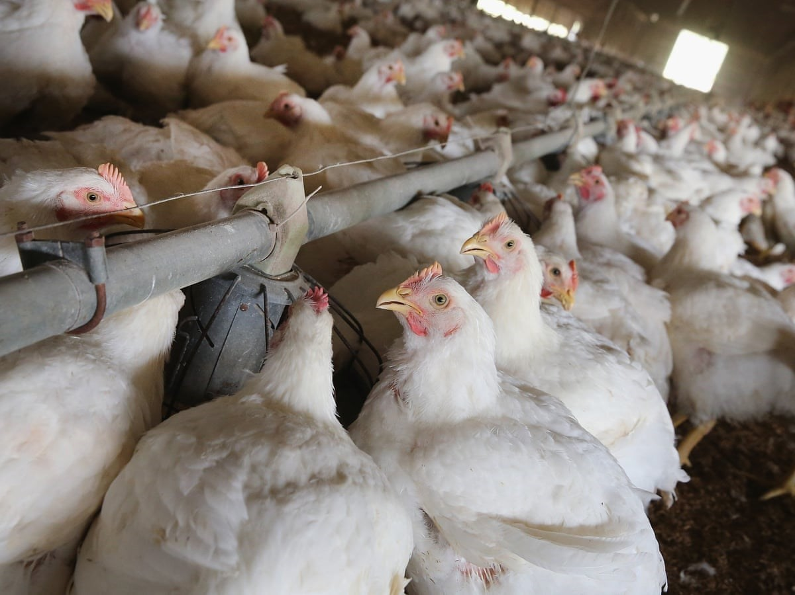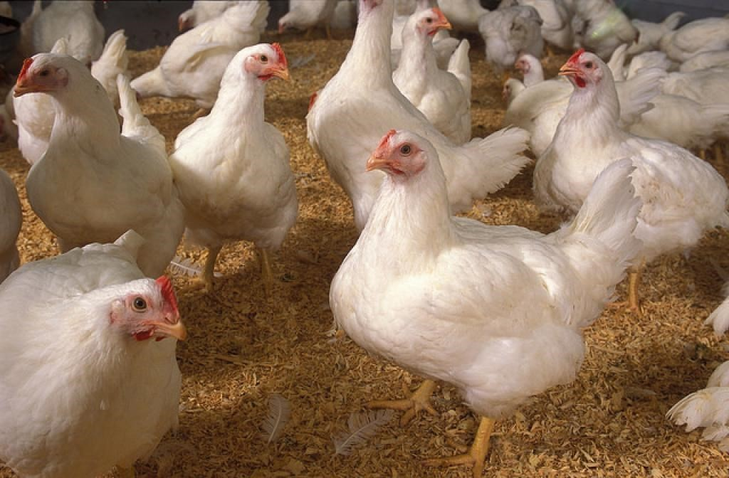

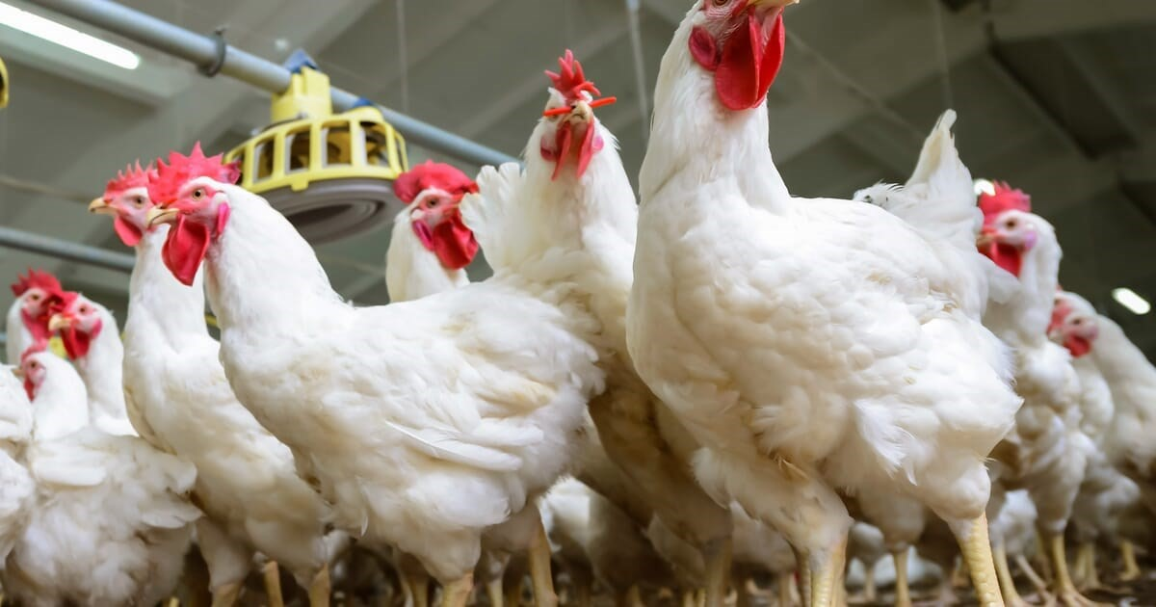
16

The Gambia Poultry Community
- The Gambia is already home to a developed community of stakeholders in the poultry industry (including businesses, industry associations and representative groups) – a few examples of these organisations are displayed below.
- The presence of these groups demonstrates The Gambia’s attractiveness and potential as a prime location in West Africa for the rearing of poultry for eggs.
EXAMPLES OF ORGANISATIONS:

Gambia Livestock  Marketing Agency | Romar Farms Gambia Ltd. | Lammeh Kunda  Poultry Farm | Gambia Commer-  cial Poultry Farmers  Association
Gambia Farmers  Platform | Empass Farm | Rue Chicken Ltd. | GreenGold Gambia  Ltd.

Location

- Poultry can be reared in many parts of The Gambia, although the Western Region has the highest concentration of commercial and backyard chickens.
- The west coast offers easy access to Banjul port and airport, while the north and south roads and navigable river ensure easy access from the rest of the country.
17

Seed Production in The Gambia

- The Gambia offers a strong investment environment for seed production in terms of demand, arable land, climate and available labour and skills
- Various seeds are currently grown in The Gambia, including oil and rice seeds.
- However, many key agricultural inputs – including seeds – are currently sourced through expensive imports.
- The Gambian Government, through various local and international partners, is committed to bolstering the country’s seed production industry.
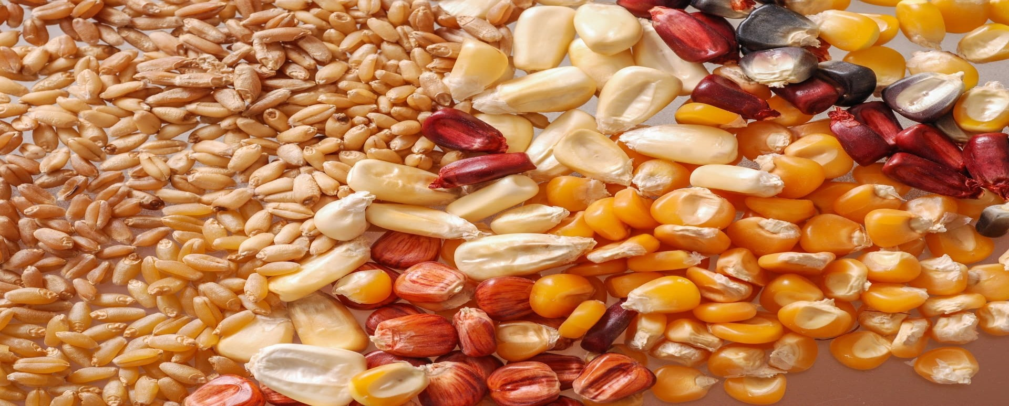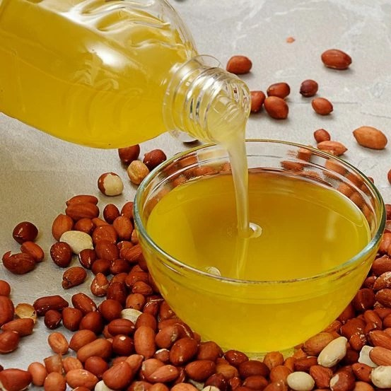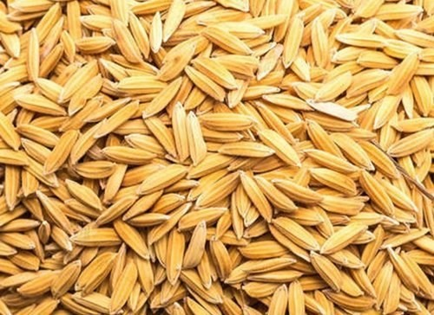
18

The Gambia’s Seed and Horticultural Community

- The Gambia is already home to a developed community of stakeholders in the seed-related and broader horticultural sector (including businesses, industry associations and representative groups). A few examples of these organisations are displayed below.
- The presence of these groups demonstrates The Gambia’s attractiveness and potential as a prime location in West Africa for the production and export of seeds.

EXAMPLE OF ORGANISATION

National Agricultural Research Institute – Seed Technology Unit | Gambian Agrochemicals and Seed Trades Association | Gambia is Good  (GiG) | New Nut Compa-  ny
Gambia Horticulture Enterprise | Gambia Farmers  Platform | ComAfrique Ltd. | Chossan Products  Trading Gambia  Ltd.
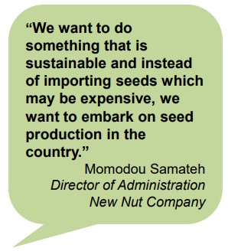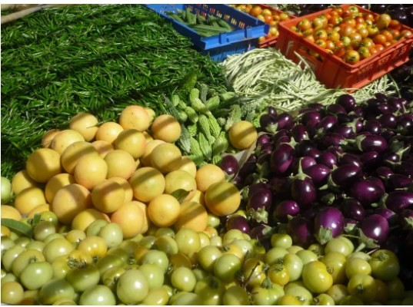
19

Location

- Current seed production and related research is concentrated in the Western Region, although seed production is possible almost all parts of The Gambia.
- The west coast offers easy access to Banjul’s port and international airport, while the north and south roads and navigable river ensure easy access from the rest of the country.

Horticultural Case Study
- ‘Gambia is Good’ (GiG) is a company that trades fresh produce in The
Gambia linking small scale farmers in The Gambia with markets in the tourism sector. The company started trading in 2004 with 30 growers.
- The number of growers has increased nearly tenfold and by March 2006, cumulative sales reached 106.8 tonnes with daily sales averaging 1 tonne.
- GiG offers a wide variety of produce throughout the year, including tomatoes, onions, cabbages, cucumbers, carrots, white radishes, lettuces, sweet peppers, hot peppers and Irish potatoes. The project has been so successful that GiG has also been exporting radishes to Senegal. It has also been procuring seeds from the Senegalese company Tropicasem.
- Successful, yet seed import-reliant enterprises, such as GiG indicate the market demand and potential for investment in quality seed production in The Gambia to reduce dependency on seed and other horticultural imports.
20

Export Agreement
Nearly all Gambian products can be exported at preferential duty rates and quota free to:
- ECOWAS markets under the ECOWAS Trade Liberalization Scheme (ETLS)
- EU market under the Everything But Arms (EBA) Initiative offered by the European Union
- US market under theAfrican Growth and Opportunity Act (AGOA)
- India, Brazil and South Korea under preferential duty rates for products from Least-Developed countries

Incentives
A host of incentives are available to investors in the agricultural sector, provided certain criteria relating to investment value and job creation are met. These incentives include:
- Tax Holiday: tax breaks on corporate and turnover tax, withholding tax on dividends and for a period of 5-8 years, depending on the project’s location.
- Import Tax Incentives: Exemption from payment of import tax on direct inputs for the project (e g agricultural machinery) and VAT.
- Export Incentives: Exemptions/reductions on corporate and turnover tax, exemption from Excise Duty and VAT on goods produced or imported within the export on agricultural export.
- No Export tax on agricultural products.

21

Government Policies

- The Gambian Government recognizes the importance of private sector participation in the economy, both as an engine of growth and as a source of knowledge transfer.
- The Gambia National Agricultural Investment Programme (GNAIP) 2011-2015 is the national strategic framework for accelerated growth, poverty reduction as well as food, nutrition and income security.
- The Gambia has been recognised by the World Economic Forum as having the best agricultural policy framework in West Africa (and the 10th best globally
- The Gambia has established the Gambia Food Safety And Quality Agency (GFSQA).
- The Government also plans to Increase the number accredited laboratories— supported by EU—Funded West African Quality Programme.

Operational Cost
- The Gambia has by far the most efficient labour market in West Africa and offers competitive costs in key areas such as agri-processing labour.
- Competitive rates for key utilities such as energy and water are offered to operators in the agricultural sectors.
- The cost of container shipments from Banjul to key European ports are broadly in line with other ports in West Africa.

22

Why invest in the Gambia
STRONG PRODUCTION LEVELS AND POTENTIAL:
- One of West Africa’s leaders in the Crop Production Index (World Bank).
- Groundnut export trade value nearly doubled.
- Around 81,000 hectares of land is irrigable.
- Demonstrated commercial successes in horticulture.
COMPETITIVE INVESTMENT ENVIRONMENT:
- Best agricultural policy framework and the most competitive economy in West Africa (WEF 2012).
- West Africa’s most efficient labor market (WEF 2012).
- Lower political risk than neighboring countries (Maplecroft).
STRONG AND IMPROVING INFRASTRUCTURE:
- River Gambia - easily accessible to ocean- going shipping.
- Efficient port with competitive costs (fixed unit tariff system).
- New and upgrade projects underway, improving transport links with ECOWAS markets.
ATTRACTIVE INCENTIVES, COMPETITIVE COSTS • Generous incentives for groundnut production.
- Competitive costs.
- Strong political support for groundnut production.
- Comprehensive guidance and support from GIEPA.

23

Why invest in the Gambia Con’d
HIGH DEMAND AND STRONG PRODUCTION POTENTIAL:
- Less than half of the national cereals requirement is produced domestically.
- Less than 60% of the country’s arable land resources is currently used.
STRONG DEMAND AND PRODUCTION POTENTIAL:
- Imports on egg has grown.
- Around 465 livestock dealers and 394 butchers registered nationally.
- Government target an increase in the supply of livestock products to the tourism sector.
- Increase in poultry imports.
- Increase in diary inputs.
- Cashew production expected to double within a decade.
- Increase in beef imports.

A helping hand every step of the way
- The Gambia Investment and Export Promotion Agency (GIEPA) is the Government Agency mandated to support companies with their investment, business and export development as well as support to MSMEs.
- From the initial provision of information right through to supporting the establishment, growth and development of an investment project, GIEPA is your supporting partner for doing business in The Gambia – every step of the way.
- Here are just a few of the ways in which GIEPA can support your business.
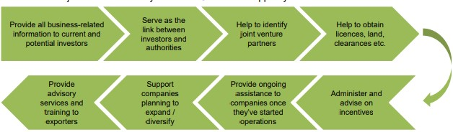
24

Reference
- Ministry of Trade, Industry, Regional Integration and Employment: Mid-term programme 2013-16
- UN Commodity Trade Statistics Database.
- GIEPA Agriculture Investment Brochure 2012.
- GIEPA Investment Guide 2012.
- Gambia Bureau of Statistics (GBOS) estimate, 2009.
- Main source: Access Gambia.
- GNAIP Agriculture Investment Plan 2011-2015.
- UN Comtrade. Accessed: 11/2/13.
- GIEPA Agriculture Investment Brochure 2012.
- Gambia Livestock Marketing Agency’s Cattle Census 2010. Reported on allafrica.com 1/2/11.
- International Relief & Development (IRD). Interviewed: 27/11/12.
- Gambia National Agricultural Investment Programme 2011-2015.
- Federation of Gambian Cashew Farmers. Interviewed: 27/11/12.
- Gambia Livestock Marketing Agency’s Cattle Census 2010. Reported on allafrica.com 1/2/11.
- Gambia Livestock Marketing Agency, reported in January 2013.
- Gambia Horticultural Enterprise (GHE).
25
